English ES1 student workbook -Character
Name:
Class:

Lesson 1
During this activity you will learn to:
- experiment with describing words (adjectives)
- engage in conversations and discussions.

1.1 Speaking and listening
Look in the kitchen and without gesturing or hand signals, describe one object in detail to an adult.
Try not to name the object. You are encouraged to use descriptive language.

1.2 Reading and viewing
Watch the shared reading video – listening, Big Rain Coming by Katrina Germein and illustrated by Bronwyn Bancroft.
Discuss the character of Old Stephen and how the illustrator cleverly creates distance from the viewer.

1.3 Writing and representing
Waiting for something can be hard! Sometimes waiting can be exciting, sometimes it fills you with fear.
Discuss waiting for something, or someone, like Christmas, a tooth to fall out or even waiting for a new sibling!
Draw a picture, showing me what you have had to wait a long time for. Add labels to your drawing or a few sentences to explain your picture.
Discuss this with an adult and record your answer.

1.4 Handwriting I i
After watching video lesson 1, practise writing the letter I, both lowercase and uppercase.
Make sure you are sitting correctly with your feet on the floor.
Hold your pencil so it rests easy in the soft spot between your thumb and your pointer finger.
Is your pencil sharp?
You’re ready to start writing!

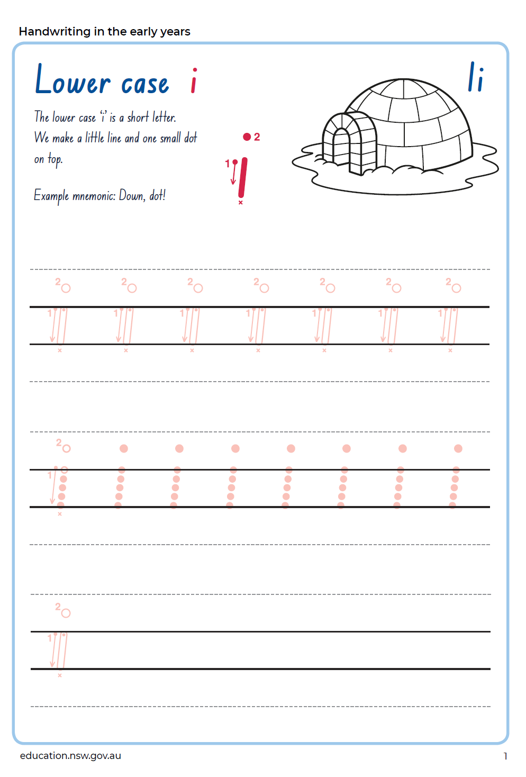

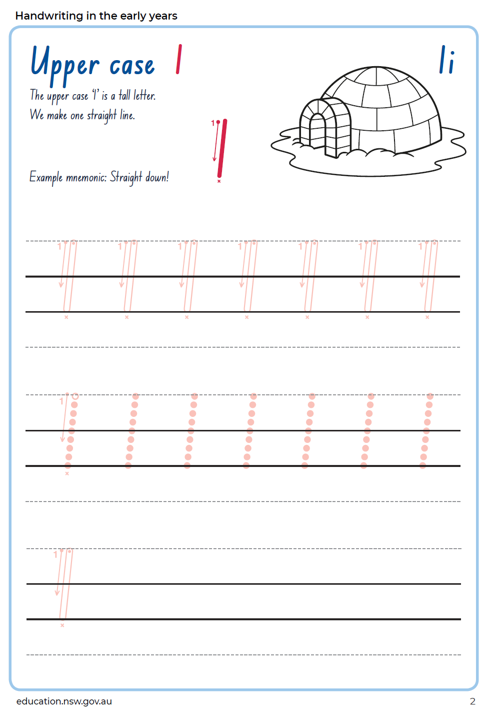 1.5 Reflection
Why is Old Stephen important to this story?
Why are characters important in any stories?

Lesson 2
During this activity you will learn to:
- experiment with describing words (adjectives) and understand the meaning they carry
- identify literal meanings presented in texts, e.g. characters, setting and events
- understand that characters can invite positive or negative responses.

2.1 Speaking and listening
Think of a familiar character from a movie or book (Spiderman, Elsa, Mickey Mouse, Pig the Pug)
Play ‘Bounce’ with an adult.
Taking turns, the player will use a word or short phrase to describe the character, including what they look like (bossy, tall, pointy ears, messy, sad, lonely).
You will take it in turns until one person can no longer think of a word. Choose another character and Bounce starts again!

2.2 Reading and viewing
Watch the Shared reading video lesson Big Rain Coming – think aloud.
Discuss the setting of this story and the similarities and differences to where you live.

2.3 Writing and representing
You have discussed the setting, where the story takes place (lesson 2.2).
Discuss the landscape and features and compare it to the landscape where you live. What are the similarities and differences? Draw your personal setting and the setting described in Big Rain Coming. Label each picture to draw attention to the similarities and differences.

2.4 Reflection
Can you think of some characters you don’t like? Some characters are very unlikeable but they’re interesting! Think about: what makes a character interesting in a text?

Lesson 3
During this activity you will learn to:
- blend through phonemes to read words with increasing degrees of confidence
- discuss new vocabulary and demonstrate growing understanding by experimenting to use them in context.

3.1 Speaking and listening
Play Eye Spy and use the learnt phonemes: a, s, t, p.

3.2 Reading and viewing
Watch Big Rain Coming, shared reading video lesson Vocabulary.
Discuss the words: echo and huddle. What do they mean? Can you demonstrate their meaning? Use them in a sentence.

Explicit phonics
Watch explicit phonics video lesson 1 and read Foldable Decodable text book 1 aloud.
Blend through the phonemes to read words.

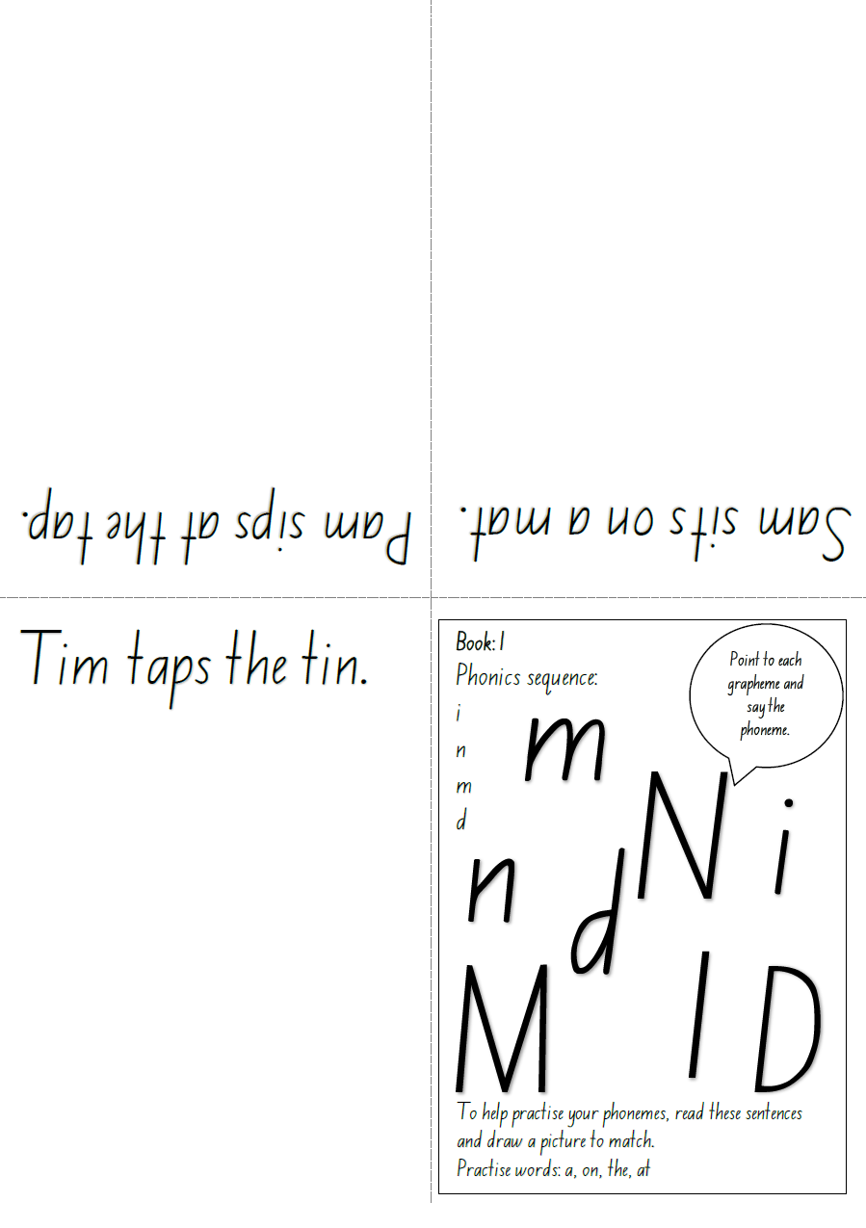

3.3 Writing and representing
When do people, animals and things ‘huddle’?
Draw a picture to describe one event of animals/people/things huddling.
Add labels or write a short description to explain your picture.

3.4 Reflection
Discuss what you can do if you get stuck when reading.
Use your voice to blend the phonemes to read words.
Practise the high frequency sight words you’ve been given. These will help you read continuous text.
Remember nobody was born reading, it’s a skill we must all learn.

Lesson 4
During this activity you will learn to:
- use adjectives to describe emotions
- demonstrate understanding of key, common adjectives through expression
- create a description of a character’s appearance and personality.

4.1 Speaking and listening
An adult will show you an emotion card.
Emotion cards
happy | surprised
excited | shocked
scared | nervous
silly | proud
frustrated | angry
You will demonstrate to the adult:
What would your face look like if you were feeling this emotion?
What would your body look like?
What is something you might say when you are feeling this emotion?
When have you felt this emotion?

4.2 Writing and representing
Select four emotion from the activity you just completed. Discuss each of them and draw an image reflecting that emotion. Can line and colour symbolise emotion? Your pictures may be about when you have felt these emotions.

4.3 Reading and viewing
Watch the high frequency sight word video 1 to learn and practise ‘in’ and ‘and’. You will need this Bingo card to play the game.
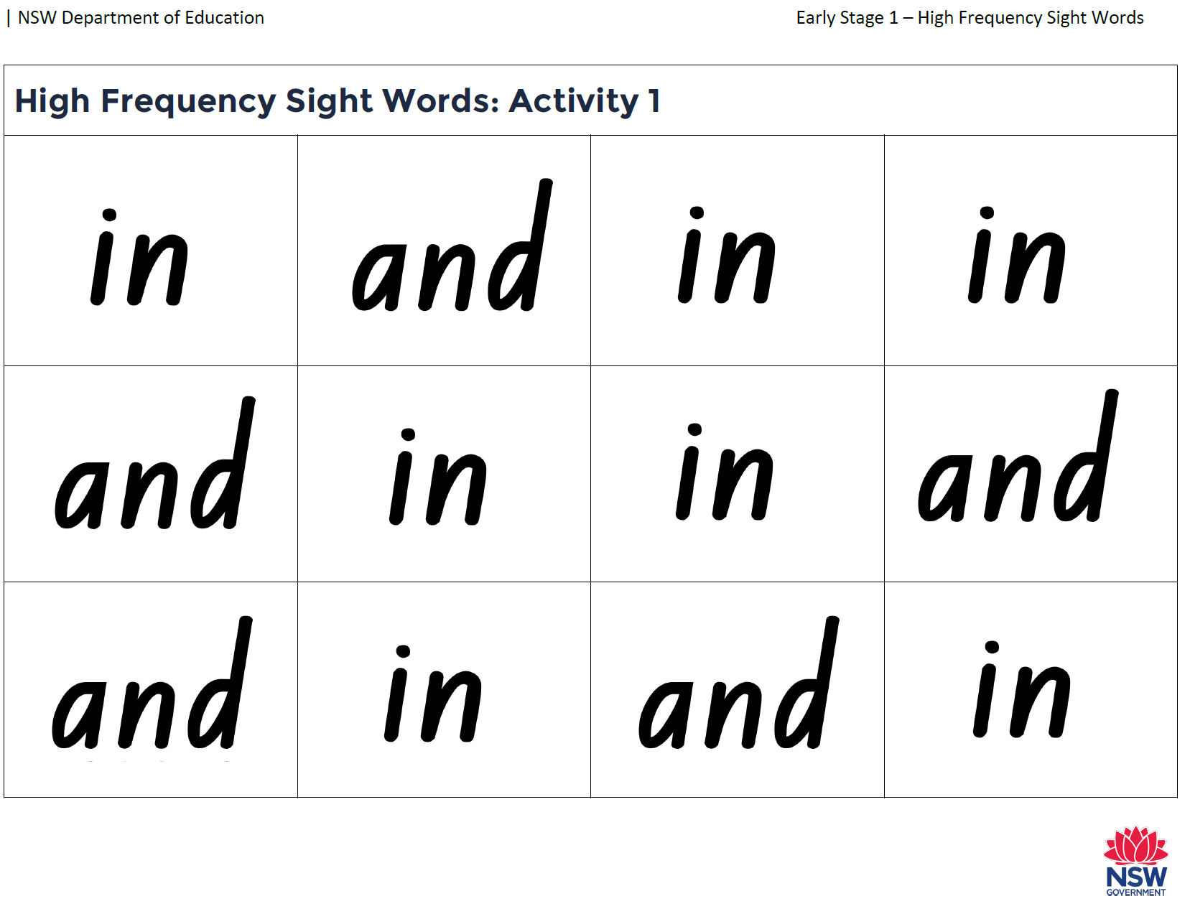

4.4 Handwriting - N n
After watching video lesson 2, practise writing the letter Nn, both lowercase and uppercase.
Make sure you are sitting correctly with your feet on the floor.
Hold your pencil so it rests easy in the soft spot between your thumb and your pointer finger.
Is your pencil sharp?
You’re ready to start writing!

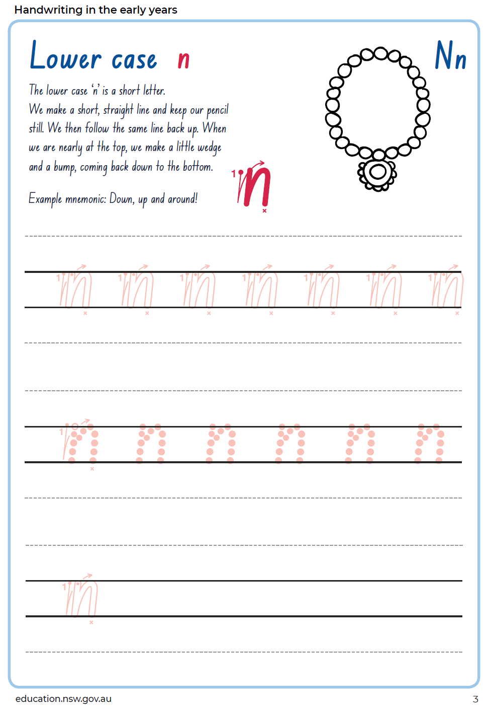
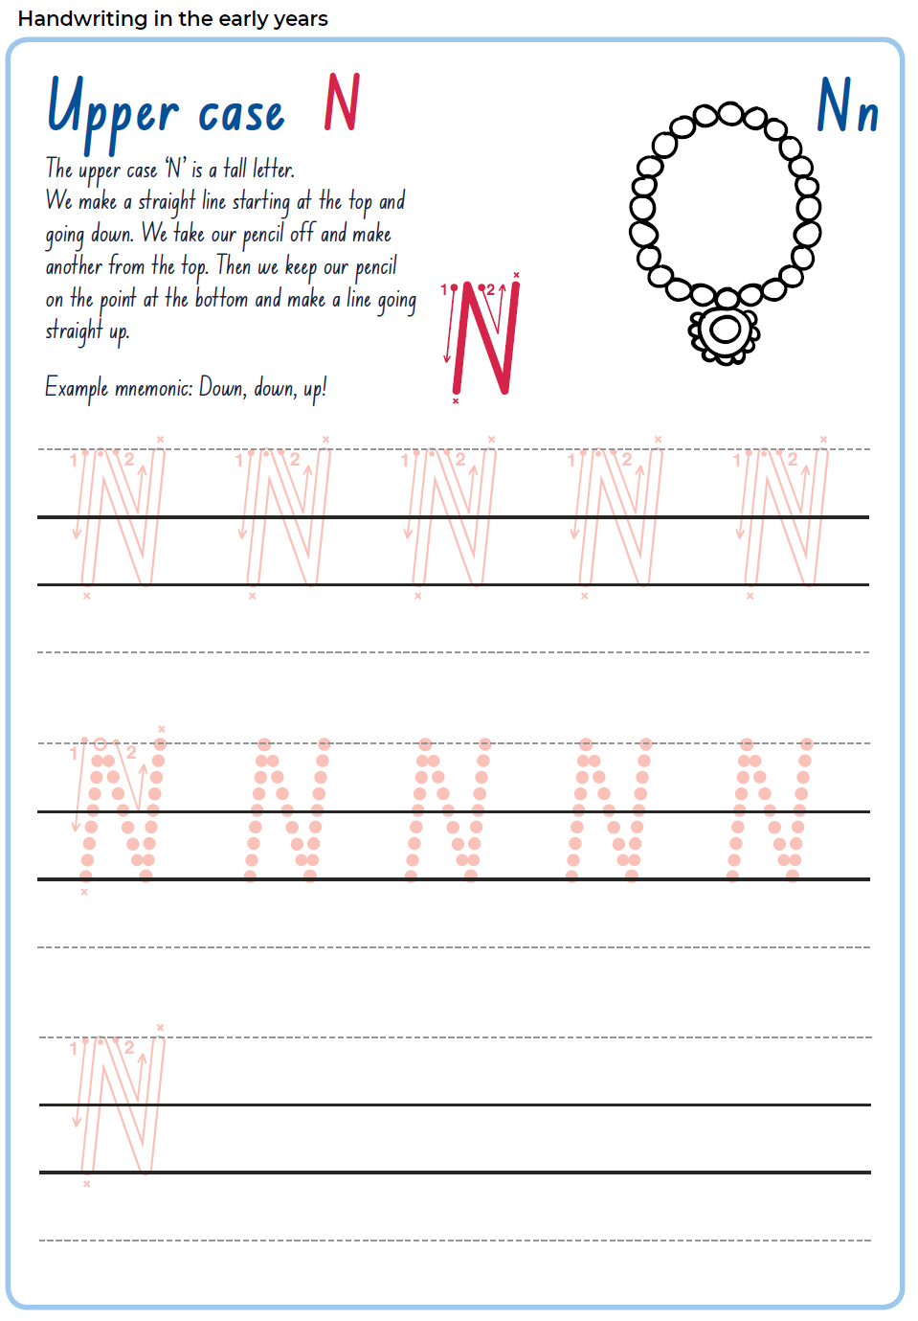

4.5 Reflection
Which emotion do you like to feel the most?
Which one the least? Why?
If everyone feels emotions, then why is it sometimes not obvious what they’re feeling?

Lesson 5
During this activity you will learn to:
- use persuasive language to convince
- recognise the typical features and structures of a narrative

5.1 Speaking and listening
Using persuasive language, attempt to convince an adult using 3 reasons why:
- you should have pets at school
- you should eat whatever they like all day.

5.2 Writing and representing
Draw 3 representations of your argument.

5.3 Reading and viewing
Watch shared video lesson – concept Big Rain Coming.
Can you identify the beginning, middle (complication) and end (conclusion) of the story?

Explicit phonics
Watch the explicit phonics video lesson 2 and read Foldable Decodable text book 2, aloud.
Blend through the phonemes to read words.

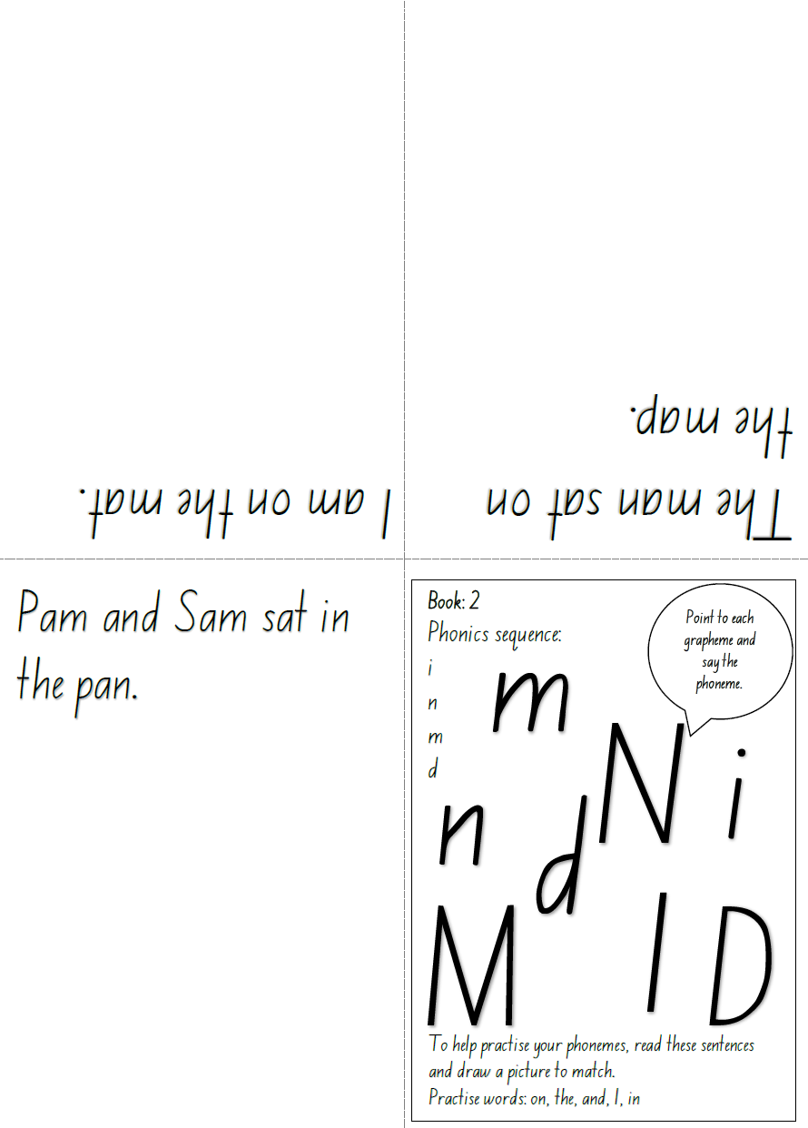

5.4 Reflection
Discuss why many narratives follow a predictable structure of beginning, middle (complication) and end (conclusion).
What happens when a narrative is not resolved?
Does every story need a conclusion?

You will role-play a familiar event in a text (book or movie), adopting the role of the known character.
You are encouraged to pay attention to voice, body language and facial expressions.
Other members of the house might also like to be involved. They could be any character. (e.g. Shrek and Donkey from the Shrek movie franchise).

Lesson 6
During this activity you will learn to:
- explore how tone, volume, pitch, articulation, body language and facial expressions contribute to communication
- identify that imaginative texts are about characters
- compare character attributes in texts.

6.1 Speaking and listening
Focusing on expression, you will say ‘How are you today?’ as a different person.
For example:
- The Queen
- a school principal
- your best friend
- a very old person
- a toddler
- the Prime Minister.
Think about your facial expression, tone and body language.
An adult may be able to record you.

6.2 Reading and viewing
Watch the shared reading video lesson – listening, Let’s get a Pup! by Bob Graham, published by Walker Books.

6.3 Writing and representing
Now you have met Dave and Rosy, brainstorm 4-6 adjectives that describe each (e.g. Rosy is broad, old, calm, trustworthy, comforting. Dave is energetic, funny, small, hairy, lovable).
Draw and label these two characters. Write a short statement, placing these adjectives into sentences.
Describe Dave | Describe Rosy
Picture of Dave | Picture of Rosy

6.4 Handwriting
After watching video lesson 3, practise writing the letter Mm, both lowercase and uppercase.
Make sure you are sitting correctly with your feet on the floor.
Hold your pencil so it rests easy in the soft spot between your thumb and your pointer finger.
Is your pencil sharp?
You’re ready to start writing!

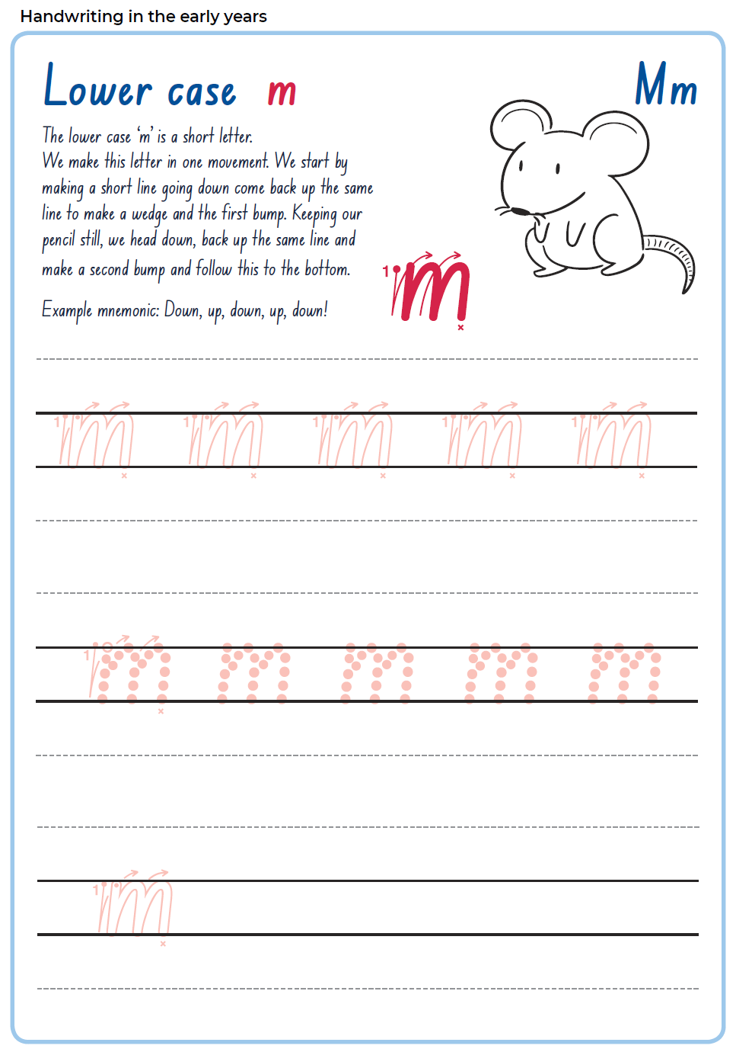

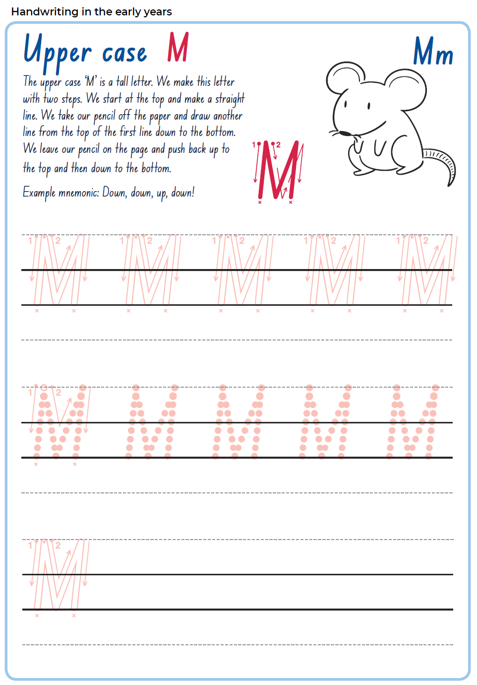6.5 Reflection
How is your handwriting? Is it legible?
What is one thing you could work on to improve it?
Discuss and share with an adult.

Lesson 7
During this activity you will learn to:
- describe in detail, familiar places and things
- create visuals that reflect character, setting and events
- make inferences about characters’ actions and feelings.

7.1 Speaking or listening
Look around your immediate space and select an item.
Describe this item to an adult without naming the item.
The adult will guess the item based on your descriptions given.
Try and use descriptive language.
Now it is the adult’s turn!

7.2 Reading and viewing
Watch the shared reading video lesson-think aloud.
How are the characters Rosy and Dave alike? How are they dissimilar? What common goals do you think they share?

Explicit phonics
Watch explicit phonics video lesson 3 and read Foldable Decodable text book 3 aloud.
Blend through the phonemes to read words.

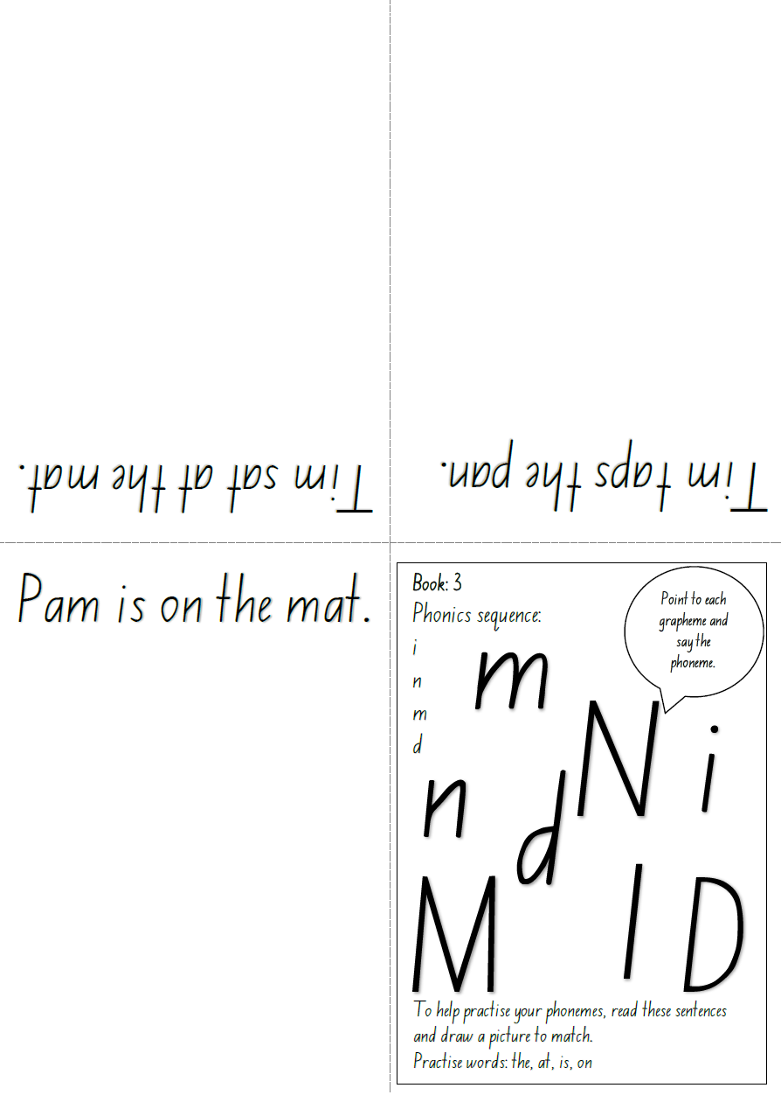7.3 Writing and representing
Imagine a conversation between Dave and Rosy. What would they discuss? The family? Their luck? Their past? Their future hopes and plans?
Draw a picture to show the conversation between the two. You might like to include labels, have a go at speech bubbles, or write a short explanation. Explain your picture to an adult.

7.4 Reflection
Discuss with an adult, what makes an interesting main character? If you were to make a movie, or write a story, what traits would you like your character to have?

Lesson 8
During this activity you will learn to:
- practise reading high frequency sight words words quickly and accurately
- make inferences about characters’ actions, motivations and feelings.

8.1 Speaking and listening
Look the characters in the movie poster your teacher has included.
What do you think of these characters? Look at what the characters wear, how they stand and their facial expressions.
What do you think their personalities are like? Will they be kind and helpful? Will they cause trouble?
Discuss your thoughts with an adult.

8.2 Writing and representing
Using the poster from the previous discussion, select one of the characters to draw and talk about. Think about:
Discuss and then comment on how they look, what you imagine their personality to be, and infer any special talents or skills they may have. What evidence do you have that these hints might be right?
Label your picture, including descriptions. Have a go at writing some sentences about your character.

8.3 Reading and viewing

High frequency sight words
Students will watch the high frequency sight word video lesson 2 and complete activity 2 of the support activities for ‘has, to, had’. The teacher can write the words on flash cards and post-it notes and routinely practise them with the students.

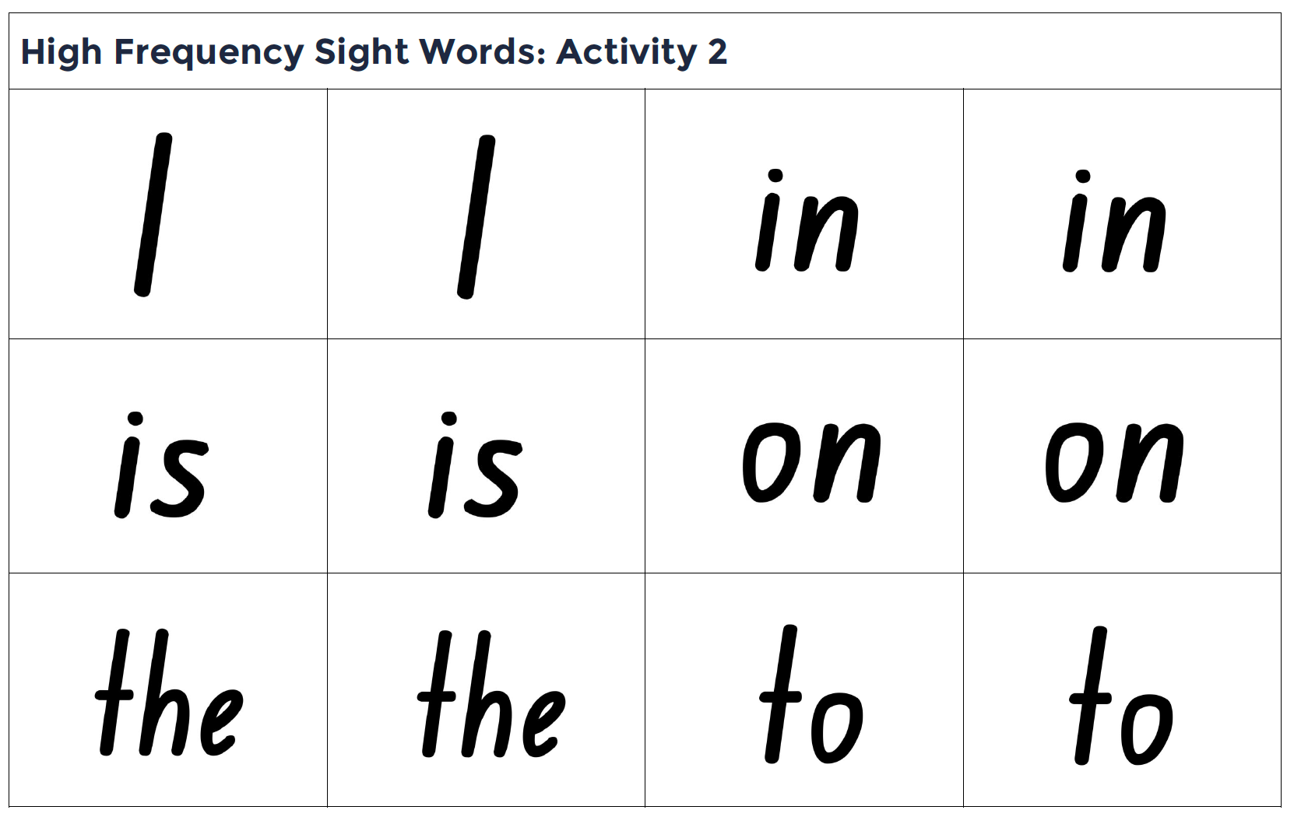
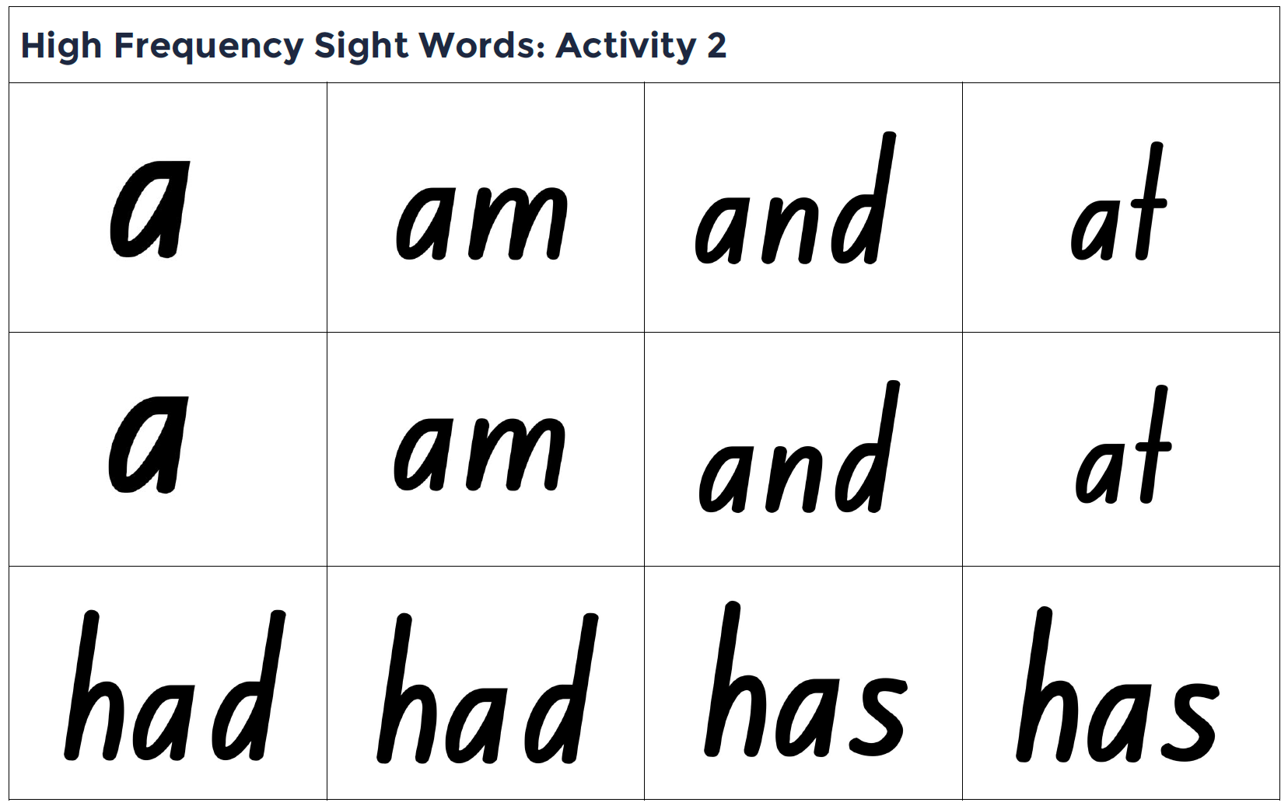

8.4 Handwriting
After watching video lesson 4, practise writing the letter ‘d’, both lowercase and uppercase.
Make sure you are sitting correctly with your feet on the floor.
Hold your pencil so it rests easy in the soft spot between your thumb and your pointer finger.
Is your pencil sharp?
You’re ready to start writing!

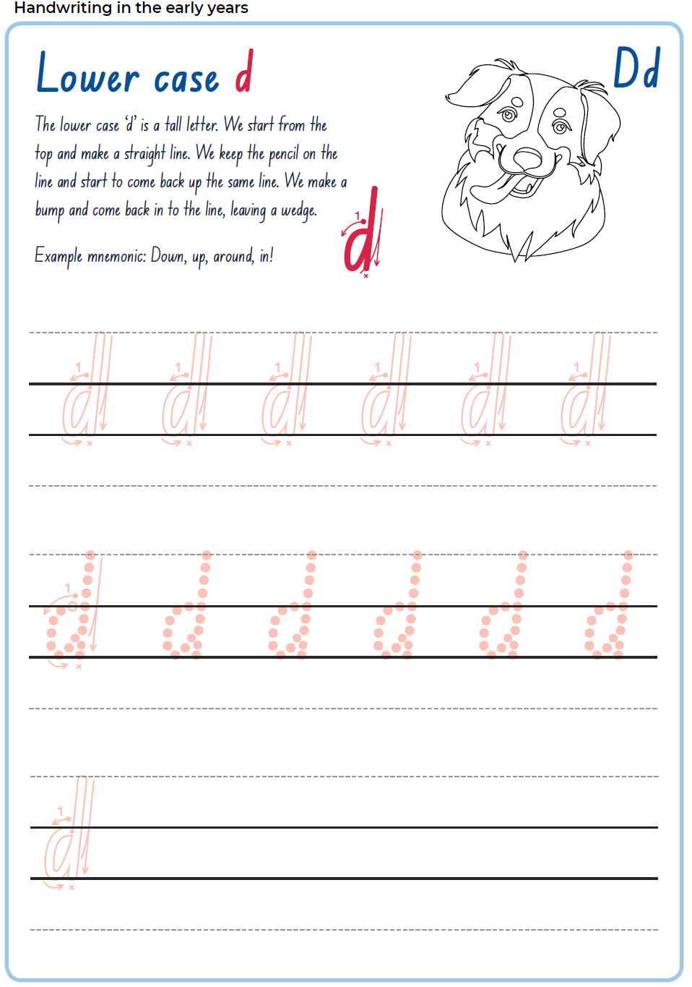

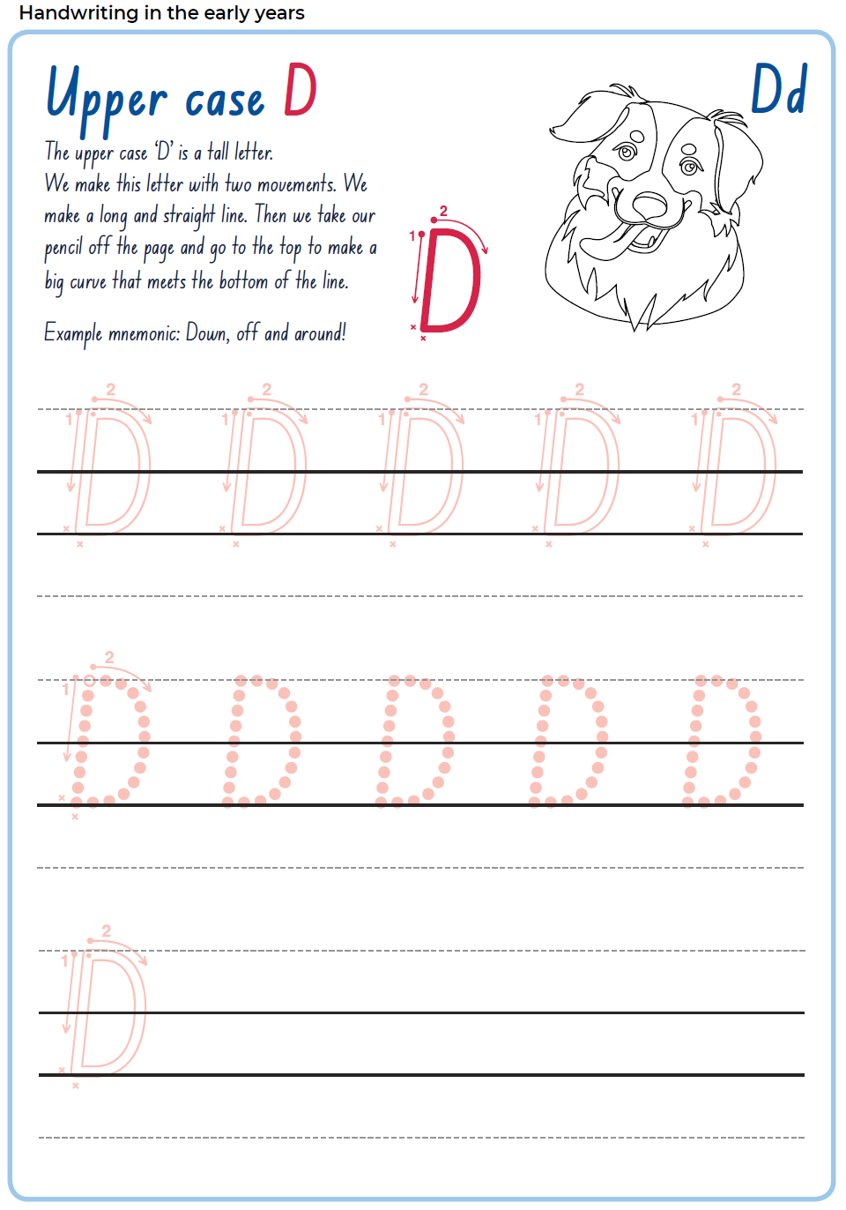8.5 Reflection
What was one thing you are doing well when reading independently?
What is one part of your reading you would like to focus on?
Discuss and share with an adult.

Lesson 9
During this activity you will learn to:
- blend phonemes to read words in continuous text
- experiment to use novel vocabulary appropriately
- identify and describe a character’s identity.

9.1 Speaking and listening
Now you’ve heard the text Let’s Get a Pup! by Bob Graham and you have talked about the characters.
Now you are going to deliver a short presentation to recommend or not recommend the story. You must support your endorsement (or not) with at least 2 reasons.
Remember to speak in a clear voice and look at your audience.

9.2 Reading and viewing
Watch the Shared reading video lesson Let’s Get a Pup! – vocabulary.

Explicit phonics
Watch explicit phonics video lesson 4 and read Foldable Decodable text book 4 aloud.
Blend through the phonemes to read words.

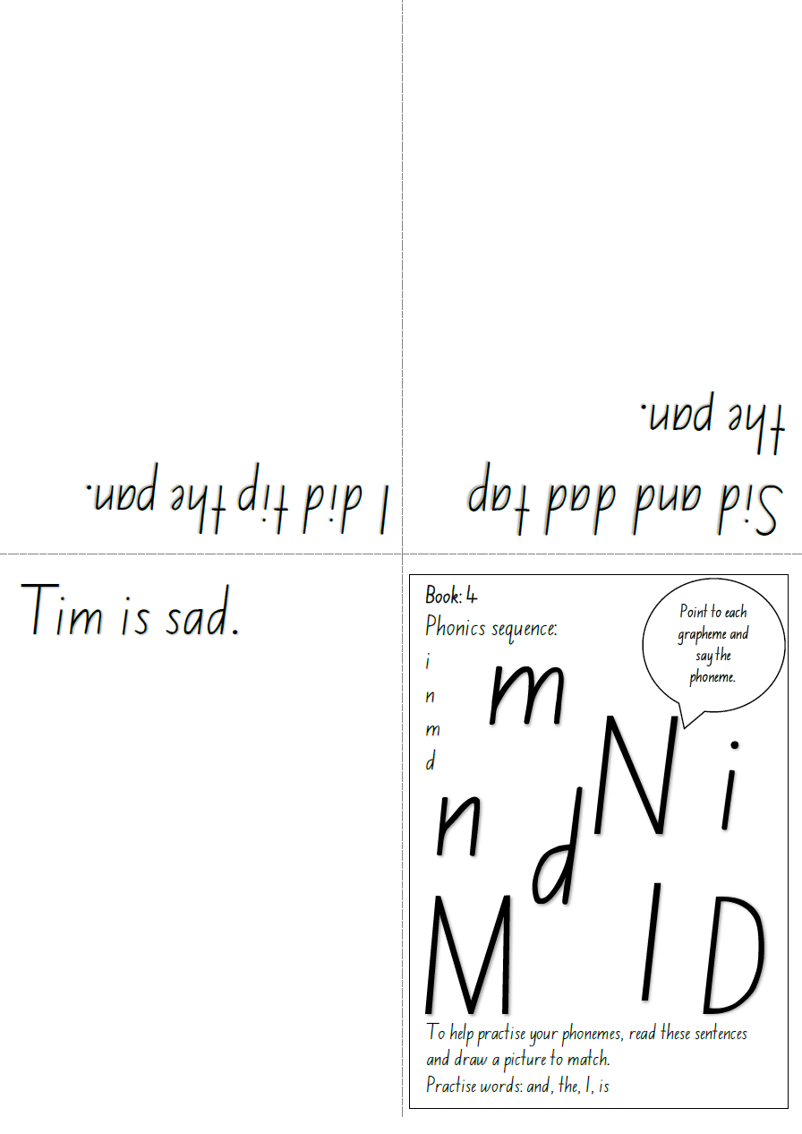

9.3 Writing and representing
Think about two of the newly introduced vocabulary, instantly and immediately. What is the opposite of instantly or immediately? Slowly is one word that means the opposite of instantly or immediately.
You are going to work with an adult to complete the sentence using ‘immediately, instantly or slowly’. For example;
When I drop a carton of juice I….clean it up.
If I am busting for the bathroom I move….
I move ….when I am sleepy,
After the joint construction, students can draw and label their own example of moving immediately, slowly or instantly.

9.4 Reflection
Why is it important we learn new vocabulary?
How does knowing and using precise words to describe things help us as readers and writers?

Lesson 10
During this activity you will learn to:
- describe in detail familiar people
- review simple imaginative texts
- read Foldable Decodable texts independently by blending phonemes to read words.

10.1 Speaking and listening
Describe a familiar person in as much detail as possible. Use descriptive words to talk about the way they:
- Move (Grandad is slow and stiff when he walks)
- Look (he has short, grey hair that is a bit thin)
- Speak (he speaks in a big, booming voice that echoes around the house)
- Act (Grandad is very gentle and kind and listens to me when I tell him about lego)

10.2 Writing and representing
Draw your familiar person with as much detail as you described in the speaking and learning activity. Label your picture or write a few sentences about your person.

10.3 Reading and viewing
Watch the Shared reading video lesson Let’s Get a Pup! – concept.
Discuss with your adult: where could this story be set? How do you know? How can you relate to this family?

Explicit phonics
Read Foldable Decodable text book 5 aloud. Remember to blend through the phonemes to read words.

10.4 Reflection
How is your writing going? Are you pleased with the progress you are making?
Discuss what you have learnt about writing and what you would like to focus on in the next few lessons.

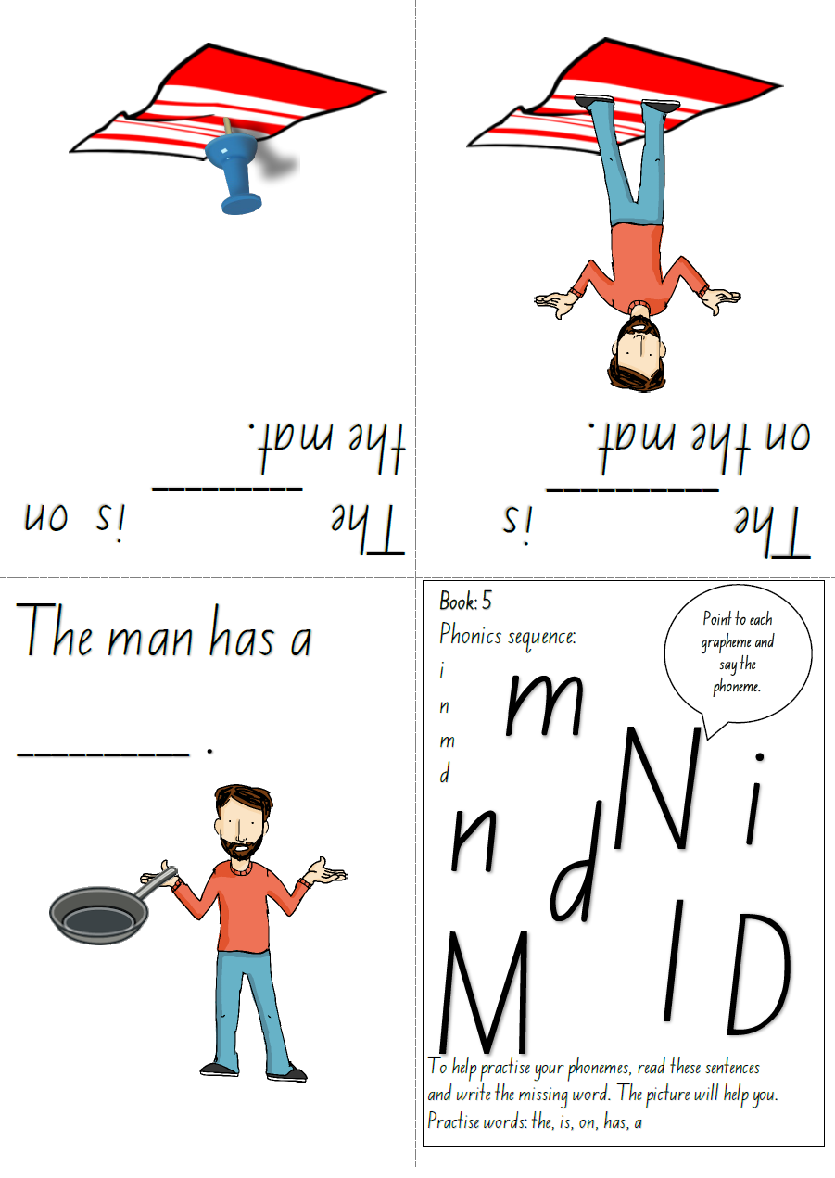My Record of Texts
‘Texts’ includes sound, print, film, digital and multimedia. It’s the way we communicate. So that means it can be a book, text message, podcast, play, website and even a movie. When we talk about text, it could be any of these communications.
Record the title of each text you engage with (or if it is a novel, you might like to record each chapter title).
Record of Texts
Date | Title | Type of text | Independent or shared | Notes
1 April | The Barber Shop Scissor Twister | comic | Shared with dad | I recommend this comic because it is funny. Dad did funny voices.

